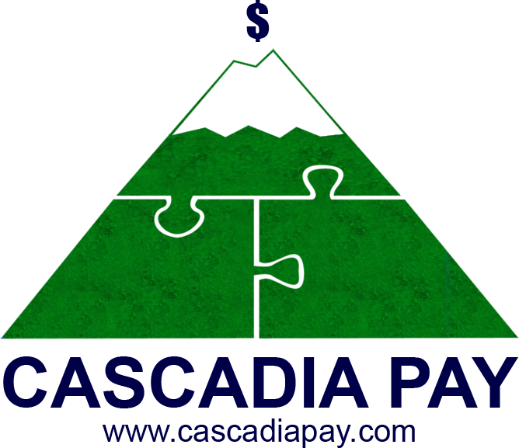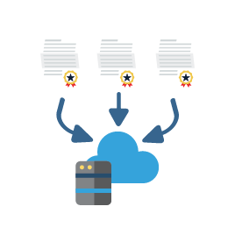

With multi-MID management capability merchants have increased control over the way their transactions are processed and reported, greater insight into their business, and save time and effort by handling all their payment processing in one user-friendly portal.

© 2017 Cascadia Pay

**Intelligent Transaction Routing**

Straightforward methodologies for intelligent transaction routing using a variety of parameters—including business type, business location, currency, and processor ID—that allow transactions to be distributed across multiple MIDs

**Get in touch with us to learn more:**

Direct: 1-250-642-6001 Toll Free in US and Canada: 1-866-873-0831 Email: gateway@cascadiapay.com Website: www.cascadiapay.com

Here are just a few of the many benefits merchants will see when they use our gateway’s multi-MID management capabilities:

**Consolidated Reporting**

Enhanced, consolidated, and more meaningful reporting located all in one interface

**One Gateway Account**

Eliminated time and hassle of opening a new gateway account for every new MID

**Manage All of Your MIDs Under One Gateway Account**

In a traditional payment gateway setting, the ratio of merchant IDs (MIDs) to gateway accounts is 1:1. While this might have worked in the past, when merchants weren’t as diversified as they are now, today’s merchant needs a more sophisticated solution to their payment gateway needs. This is where our gateway’s multiple MID management capability delivers results.

Our gateway’s system architecture frees a merchant from the constraints of a 1:1 MID-to-gateway account relationship and enables them to manage a virtually unlimited number of MIDs using a single gateway account.

Multiple MID Management