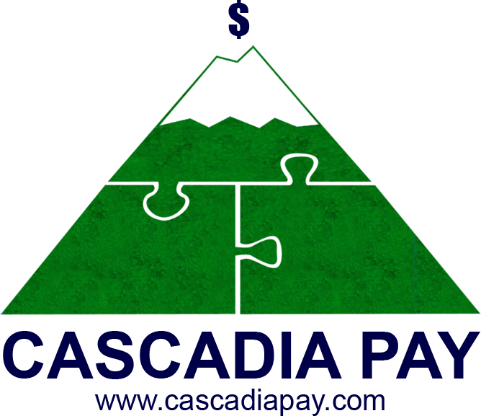
Gateway Comparison

Other Gateways
Get in touch with us to learn more:
Direct: 1-250-642-6001 Toll Free in US and Canada: 1-866-873-0831 Email: gateway@cascadiapay.com Website: www.cascadiapay.com
© 2017 Cascadia Pay
CORE FEATURES
Domestic & International Currencies Accepted
All Major Cards Accepted
Virtual Terminal
Recurring Billing
Reporting Capabilities
Third-Party Processor Integrations
Third-Party Shopping Cart Integrations
Merchant Portal
Multi-Mid Capabilities
Transaction Load Balancing
Product/Inventory Manager

Gateway Comparison

Other Gateways

Get in touch with us to learn more:
Direct: 1-250-642-6001 Toll Free in US and Canada: 1-866-873-0831 Email: gateway@cascadiapay.com Website: www.cascadiapay.com

© 2017 Cascadia Pay
ACCEPTANCE METHODS
POS Application
Mobile Payments
Encrypted Devices
Hosted Payment Form
Digital Payment Solutions
Electronic Check
Batch Processing
EMV Capability
DATA SECURITY
Fraud Scrubber
Tokenization & Securely Storing Customer Info
Verified by Visa/Mastercard SecureCode
PCI Certification Tool
Account Updater

Gateway Comparison

Other Gateways
BACK OFFICE TOOLS
Quickbooks™ Plug-In
Electronic Invoicing
Level III Processing
Gateway Emulator
Convenience Fee/ Surcharge Support
DEVELOPER RESOURCES
Gateway APIs
Mobile API/SDK
Out of Scope APIs
Custom Configurable API Responses
EMV SDK

Get in touch with us to learn more:
Direct: 1-250-642-6001 Toll Free in US and Canada: 1-866-873-0831 Email: gateway@cascadiapay.com Website: www.cascadiapay.com

© 2017 Cascadia Pay]

