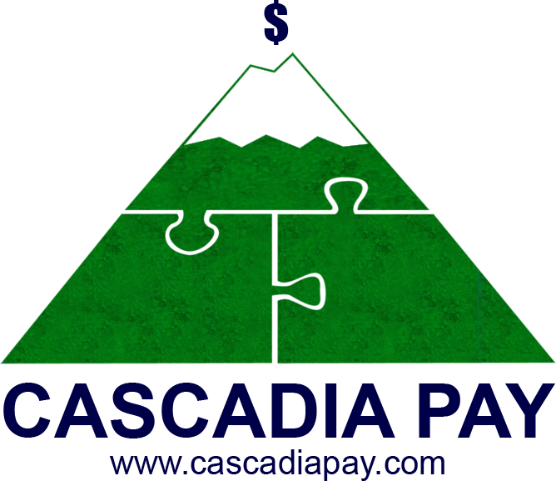Macintosh HD:Users:lpuchalski:Desktop:CC-lock-01.epsMacintosh HD:Users:lpuchalski:Desktop:down-01.epsMacintosh HD:Users:lpuchalski:Desktop:browser-2-01.eps

Here are just a few of the many advantages merchants will see when they use our gateway’s Three Strep Redirect API:

**How it works:** Catherine, the customer, navigates to Wally’s website to purchase his famous wallpaper. Catherine picks out her favorite designs and proceeds to checkout. Catherine’s wallpaper selections are itemized in the shopping cart and an invoice is created, which is sent to the payment gateway. The payment gateway receives the invoice from Wally’s site and responds by providing a URL that seamlessly redirects Catherine to a secure page where she can enter her sensitive payment information right to the payment gateway, bypassing Wally’s site completely. The payment gateway combines information from the invoice with Catherine’s sensitive payment information and returns Catherine back to Wally’s site. Upon her return, Wally receives a token from the payment gateway confirming the terms of the transaction. From here, suggested items can be shown for Catherine to consider for purchase or gateway can be instructed to process the transaction.

***All of the above takes place in just a few seconds!***

**Minimize Cost & Complexity**

By taking merchants outside the scope of handling sensitive payment information, the Three Step Redirect API minimizes the cost and complexity of industry regulations and standards; especially the Payment Card Industry Data Security Standard (PCI DSS).

**Maintain Same Look & Feel**

The customer never knows they left the merchant’s website. The same seamless look and feel is always kept through the process.

**Never Touch Sensitive Information**

Our Three Step Redirect API methodology ensures secure data transmission by keeping merchants from seeing, touching, handling, transmitting and even storing any sensitive information.

The challenge: everyday, merchants deal with the ongoing threat of thieves breaching their servers or having to discover their customer’s personal data has been compromised. According to the US Bureau of Statistics, in just one year 7,818 businesses reported data breaches.

**Three Step Redirect API**

© 2017 Cascadia Pay

**Get in touch with us to learn more:**

Direct: 1-250-642-6001 Toll Free in US and Canada: 1-866-873-0831 Email: gateway@cascadiapay.com Website: www.cascadiapay.com

Three Step Redirect API